Shirley Meneice Horticulture Conference
September 15-18, 2024
Chicago Botanical Garden
Participants:
- Mary Meyer – Lake Minnetonka Garden Club, Zone XI Horticulture Representative
- Nancy Guldberg – Lake Minnetonka Garden Club Horticulture Chair

We arrived in Boston early Saturday evening in time for a dinner with other conference goers and organizers.

Hort learnings
  - Sunday, September 15
Pre-trip
    - Crab Tree Farm
    - Camp Rosemary
    - Mettawa manor
On waitlist for Pre-trip so….7 of us on the waitlist headed into downtown Chicago
    - Chicago River Architectural boat tour

    - Visit to the Millennium Park and its “secret garden”, Lurie Garden – I shared the secret passage that goes into the arborvitae hedge at the Lurie
Dinner Speaker: Jack de Vroomen
Jack de Vroom owns and operates a third-generation family business that sells bulbs and other perennials to the trade. Along with his manager, Jill Selinger, they discussed the spring varieties (old and new), how they are propagated and distributed worldwide. I would like to say more, but the audio system was so poor I only heard about 1 of every 4 words.
  - Monday, September 16 – Day 1 – Chicago Botanical Garden
    - During breakfast a table set up for seed sharing – we brought back things to share with the club.
    - AM Speaker Fred Spicer: What It Takes to Become a Premier Botanical Garden
Fred Spicer is the Executive Vice President and Director of the Chicago Botanical Garden. He introduced us to the 52-year history, of the garden, showing images of where they started and where they are today. He took us behind the scenes with pictures of the garden’s creation.
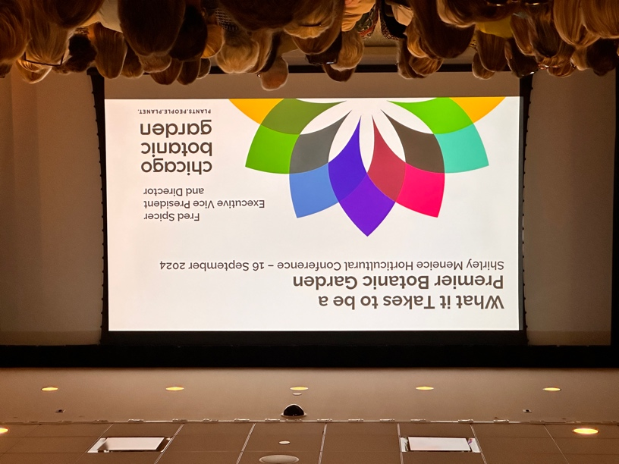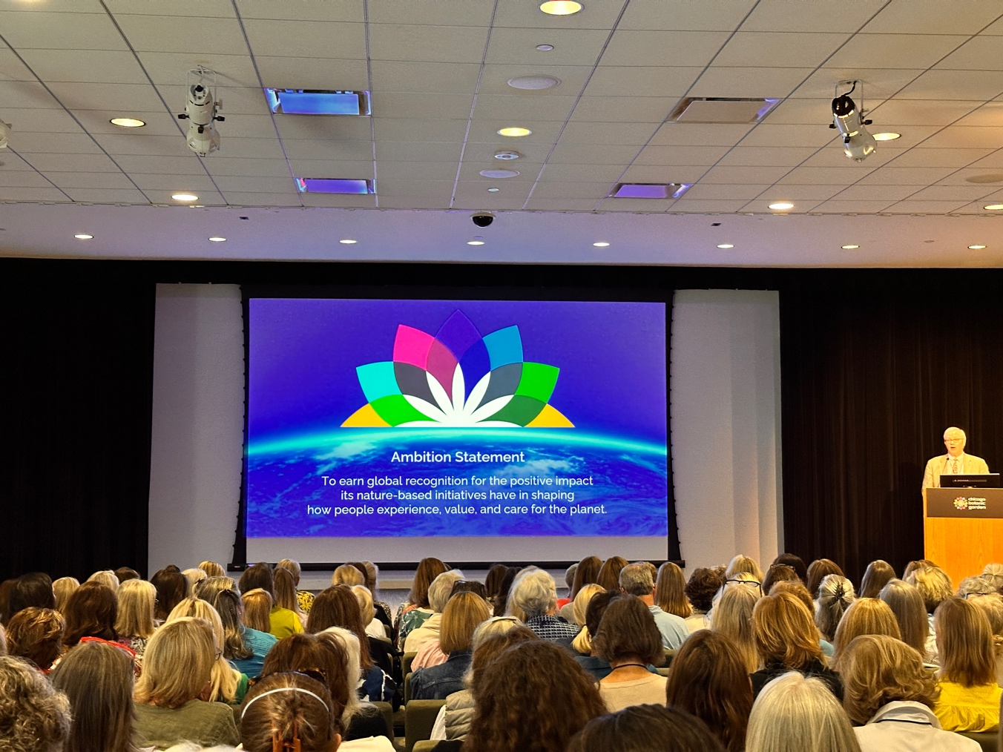
Interesting note….rather than a Mission Statement, Fred Spicer spoke to the Ambition Statement of the Botanical Garden (Pictured above). The garden has an impressive 3 million documented plants, four national collections, and is an AAM accredited Museum.
Fred had a few other things to say about plant breeding. That inbreeding is bad for plants. Farming pesticides and loss of habitat are eating away at the pollinator population. Because of these things, farmers are becoming more aware of cross breeding plants from other places as well ad planting pollinator ditches to provide corridors for migrating insects and birds. Boxwood blight is a major concern both here in the states as well as Europe.

    - AM Speaker Carrie Waterman – GCA Initiatives
Carrie Waterman encouraged everyone to consider nominating a plant for the 2026 Freeman Medal. The plant is to be an underutilized native that is a herbaceous perennial. Information on how to submit and deadline can be found at https://www.gcamerica.org/members/freeman-medal-instructions. For questions or help with a nomination email freemanmedal@gcamerica.org. The 2026 nomination form is online now.
GCA publications are online and can be found by logging into the GCA website and going to publications. There are 6 including our outstanding Bulletin, ConWatch (conservation topics and concerns), Focus (photography publication with tips and images produced by our membership), The Real Dirt (featuring in-depth articles and handy tips for gardeners of all levels), Call to Action (requests for GCA club members to contact their legislators in support of particular bills, actions, or other matters related to the GCA's purpose), and By Design (full color, floral design magazine).
Native Plant Month is now occurring in 47 states and is permanent in 6 of those states.
    - Morning Session: Zone Meeting Breakouts
The Zone XI Hort meeting was hosted by our own Mary Meyer. Thirty-eiight Zone XI participants shared ideas for engaging club members in horticulture learnings.
    - Afternoon Tours in Lake Forest
The afternoon consisted of visits to 4 amazing gardens
      - Craig Bergmann’s Home – Landscape Architect that uses the grounds of his home as his demonstration gardens for his customers to see the plants that “work” in the Chicago area. Information on Craig and his business can be found at https://craigbergmann.com
      - Elawa Farms – Historic farm established in 1917. Property today is used to demonstrate sustainable farming practices and used for both formal and informal education on the topic of sustainable gardening. Property contains and culinary center, market and food-access initiatives.
      - Three private Homes in Lake Forest – Homes included an Italianate villa, Georgian Revival home, and the Chandler House on 35 acres of restored prairie. Gardens were amazing with the Chandler House bosting a very large restored prairie.
      - Jean and John Greene Nature Preserve – A 61-acre preserve restored and open to the public. There are miles of hiking trails.
    - Dinner Speaker – Jack Pizzo, Re-establishing and Maintaining Native Prairie Plantings
Jack Pizzo, founder of the Pizzo Group of Leland, Illinois, addressed large scale re-establishments of native prairies.
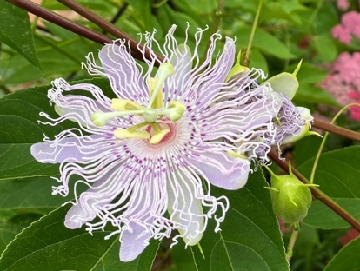
  - Tuesday, September 17 – Day 2 – Chicago Botanical Garden
    - 2024 Freeman medal Winner: Passiflora incarnata, Passionflower,
Proposed by: Cheryl Welch, The Garden Club of Jackson, Zone IX
Seconded by: Katie Breese, The Garden Club of Jackson, Zone IX
Nomination forms for the 2026 Freeman Medal can be found at: http://form.jotformpro.com/form/51585246224960
    - AM Speaker 1: Dr. Christie Klimas: Conservation through Collaboration
Christie (GCA Scholar) shared a historical perspective of what has happened to our forests in just the last 45 years. Driving the loss of forestation are: community-driven deforestation, shifting agriculture practices, forestry, wildfire and urbanization. She also shared a project called, Evanston Host Plant Initiative, Native flowers for the Rusty patched Bumble Bee. She addressed the value of home gardeners and home gardening, as citizen scientists, providing corridors of host plants for the bumble bees. These corridors make for continuous pathways for the bees and other pollinators. Extensive data was collected throughout Evanston that showed how a once “food desert” for pollinators was transformed into a continuous feast of sorts for all pollinators.

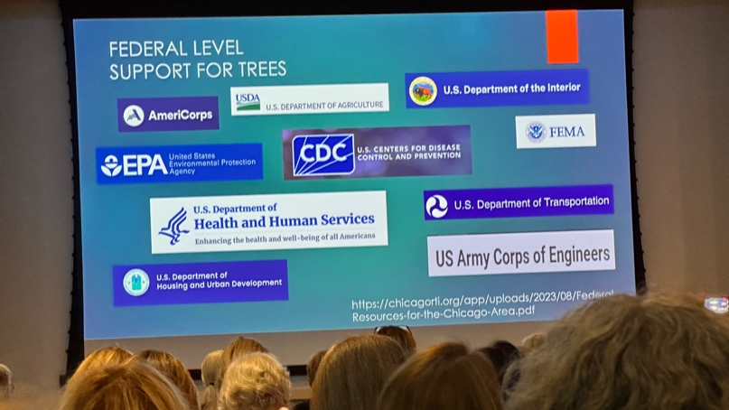
    - AM Speaker 2: Lydia Scott – Adding Trees to Our Urban World
The value of trees should not be underestimated was the main theme of Lydia’s talk. She shared information about how heat is reduced in areas with tree cover, and that trees had a large impact on positive social feelings within a community…vandalism, and other crimes are diminished, families utilize the outside and nature more freely.
“Heat is the deadliest extreme weather event, killing more people than hurricanes, floods and tornadoes combined,” Centers for Disease Control and Prevention. She suggests that we all make a plan for progress within our own communities and those surrounding us.
Lydia’s talk included a wealth of information for those seeking financing for big plant initiatives. Listed below are places where large funds are available to cities and organizations.
Trees are helpful in the following ways
- Trees can make a 15degree difference in temperature on hot days
- Trees reduce flooding. Their helps shed water more slowly
- Forest bathing is a real thing for reducing stress

\’];”:?.
    - PM Breakout sessions
Participants choose from a collection of breakouts. These are the ones we attended:
Ask Mary if she attended different ones
      - Lily Lust presented by Patsy Smith, Hort Judge, Winchester-Clarke, Zone VII. This session discussed the types of lilies, when they bloom and how to care for and show lilies. By selecting specimens from all of the categories of lilies, you can have lily blooms May – August.
      - Bonsai: CBG has 300+ bonsai trees. We met with the curator of the trees and he talked about professional tree care as well as how the more casual “home” gardener could care for the little guys. He shared the tools he worked with and identified the “basic” tools needed…. all of which could be purchased at local home improvement stores. Interesting fact, while a miniature tree could be turned into a Bonsai, actual bonsai trees are full size trees, trained and manipulated to remain small.
      - Healthy Soils = Healthy Plants = Beautiful Gardens presented by Tom Tidddens, Supervisor of Plant Health Care for Chicago Botanical Garden. Tom shared the process that CBG goes through when creating and re-designing gardens on the ground. He discussed the difficulty of keeping trees and plantings healthy. His general formula for those of us with clay soil…. FIRST, have a soil test. Find out the composition of silt, sand and clay you have, test for phosphorous, potassium and nitrogen levels and the ph of the soil. From there you can decide how best to amend the soil. His suggestion for clay: you will be adding coarse sand (not sandbox sand, but coarse san).
His basic recipe:
        - 50% soil from your yard/garden -
        - 25% coarse sand - Coarse sand has a grain size of 0.5-1.0mm. This means when passed through a #35 sieve a 65-75% of the sand will pass through. …if you purchase horticulture sand, it should be the right coarseness.
        - 25% high quality compost.
High quality compost has active organic matter. Tom suggests you ask your supplier if in fact the compost is active organic compost. He also says that they will probably look at you like you are crazy…. like they have NO idea if what you are talking about! If your compost is healthy, there will not be a need to enhance the soil with fertilizer.
        - PLUS 5% biochar -…yes….this makes for 105% ☺
Tom suggests that the biochar adds a little extra punch to the mix. In their test plots, the plots that had biochar added to any of their text mixes it demonstrated enhanced performance on the of whatever plants were in the ground.
    - Evening Presenter – Ernest C. Wong: Changing Communities One Garden at a Time
Ernest Wong is Founder and Principal, Site Design Group, LTD. Ernest has been instrumental in the evolution of the landscape of Chicago, transforming available space in neighborhoods all across Chicago into welcoming family-friendly spaces. He also transformed the Chicago River front. His talk was both entertaining and inspiring.
Other learnings
- Collaborating with others from all around the country.
  - Hearing how they conduct Hort offerings for their clubs
  - Gaining friends all around the country
  - GCA committee crossovers, how they work together
    - Horticulture
    - Conservation
    - NAL
  - Crossovers with other committees
    - Visiting Gardens
    - Civic Improvement
    - Photography
    - Flower Shows
  - Finding and sharing resources
    - Individuals can make a difference
- Next year Shirley Meneice Hort Conference is virtual – everyone is encouraged to attend.

Books
- Silent Spring, Rachel Carson - Published in 1962, Silent Spring documents the environmental harm caused by the indiscriminate use of DDT, a pesticide used by soldiers during WW2. Craigbergman.com
- Last Child in the Woods, Richard Louv – Published in 2006, Last Child in the Woods is the first book to bring together a new and growing body of research indicating that direct exposure to nature is essential for healthy childhood development and for the physical and emotional health of children and adults
- In This Ravishing World, Nina Schuyler – Published in 2024, In this Ravishing World is a sweeping, impassioned short story collection, ringing out with joy, despair, and hope for the natural world. Nine connected stories unfold, bringing together an unforgettable cast of dreamers, escapists, activists, and artists, creating a kaleidoscopic view of the climate crisis.

